Writing Alpha and Beta Decay Equations

First off, you need to know how to write and understand nuclear symbols:
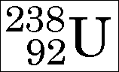
Remember that the lower number is the atomic number and the upper number is the mass number.

Alpha Decay
In 1899, Ernest Rutherford wrote the following words:
"These experiments show that the uranium radiation is complex and that there are present at least two distinct types of radiation - one that is very readily absorbed, which will be termed for convenience the alpha-radiation, and the other of more penetrative character which will be termed the beta-radiation."
Alpha decay can most simply be described like this:
1) The nucleus of an atom splits into two parts.
2) One of these parts (the alpha particle) goes zooming off into space.
3) The nucleus left behind has its atomic number reduced by 2 and its mass number reduced by 4 (that is, by 2 protons and 2 neutrons).
There are other points, but the three above are enough for this class. Here is a typical alpha decay equation:
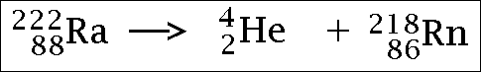
Notice several things about it:
1) The atom on the left side is the one that splits into two pieces.
2) One of the two atoms on the right is ALWAYS an alpha particle.
3) The other atom on the right ALWAYS goes down by two in the atomic number and four in the mass number.
Here's another example:
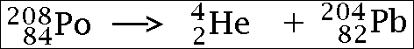
Check it and compare the three points to the example. Keep in mind that this equation shows the left-hand side splitting into the two pieces shown on the right-hand side.

Beta- Decay
Beta decay is somewhat more complex than alpha decay is. These points present a simplified view of what beta decay actually is:
1) A neutron inside the nucleus of an atom breaks down, changing into a proton.
2) It emits an electron and an anti-neutrino (more on this later) which go zooming off into space.
3) The atomic number goes UP by one and mass number remains unchanged.
Here is an example of a beta decay equation:
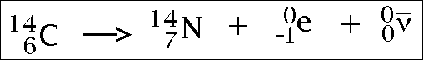
Some points to be made about the equation:
1) The nuclide that decays is the one on the left-hand side of the equation.
2) The order of the nuclides on the right-hand side can be in any order.
3) The way it is written above is the usual way.
4) The mass number and atomic number of the antineutrino are zero and the bar above the symbol indicates it is an anti-particle.
5) The neutrino symbol is the Greek letter "nu."
Here is another example of a beta decay equation:
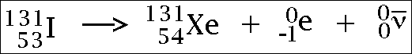
Notice that all the atomic numbers on both sides ADD UP TO THE SAME VALUE and the same for the mass numbers.

A Brief Note on the Antineutrino
As beta decay was studied over the years following 1899, it was found that the same exact beta decay produced an electron with variable energies.
For example, let us study Li-8 becoming Be-8. Each atom of Li-8 produces an electron and the theory says all the electrons should have the same energy.
This was not the case.
The electrons were coming out with any old value they pleased up to a maximum value, characteristic of each specific decay.
To make a long story short, Wolfgang Pauli (in about 1930 or so) suggested the energy was being split randomly between two particles - the electron and an unknown light particle that was escaping detection. Enrico Fermi suggested the name "neutrino," which was Italian for "little neutral one."
The neutrino itself was not detected until 1956 and the discoverers informed Pauli just a few months before his death due to cancer. Later on, it was discovered that it was an antineutrino that was produced in beta decay.
Note: Since your textbook does not include any information on the “Neutrino”, I have left it out of my examples in class.

Positron Decay
Positron decay is like a mirror image of beta decay. These points present a simplified view of what positron decay actually is:
1) Something inside the nucleus of an atom breaks down, which causes a proton to become a neutron.
2) It emits a positron and a neutrino which go zooming off into space.
3) The atomic number goes DOWN by one and mass number remains unchanged.
Here is an example of a positron decay equation:
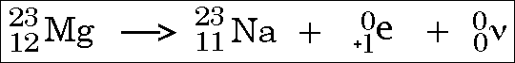
Some points to be made about the equation:
1) The nuclide that decays is the one on the left-hand side of the equation.
2) The order of the nuclides on the right-hand side can be in any order.
3) The way it is written above is the usual way.
4) The mass number and atomic number of the neutrino are zero.
5) The neutrino symbol is the Greek letter "nu."
Here is another example of a positron decay equation:
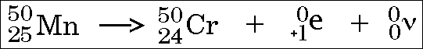
Notice that all the atomic numbers on both sides ADD UP TO THE SAME VALUE and the same for the mass numbers.

