History of the SI
Notes on the S.I. (used to be called the Metric system)

Brief Historical Intro
The first standardized system of measurement, based on the decimal was proposed in France about 1670. However, it was not until 1791 that such a system was developed.
It was called the "metric" system, based on the French word for measure. The driving force was the growing importance of weights in the sciences, especially chemistry. At that time, every country had their own system of weights and measures. England had three different systems just within its own borders!!
On May 20, 1875, delegates of 17 countries signed the Meter Convention. It was amended in 1921 and today 48 countries are signatories.
The modern metric system has been renamed Systeme International d'Unites (International System of Units) and is denoted by the letters SI. SI was established in 1960, at the 11th General Conference on Weights and Measures. It was then that units, definitions, and symbols were revised and simplified.
There are three major parts to the metric system: the seven base units, the prefixes and units built up from the base units. Here is a list of the base units which make up the metric system:
Physical Quantity | Name of SI unit | Symbol for SI unit
length | metre (meter) | m
mass | kilogram | kg
time | second | s
electric current | ampere | A
temperature | Kelvin | K
amount of substance | mole | mol
luminous intensity | candela | cd
Prefixes were also agreed on in 1791 The set from kilo- down to milli- was developed then. For the multipliers (prefixes greater than 10), Greek was used and for the fractions (prefixes less than 1), Latin was used.
In 1958, the International Committee on Weights and Measures added Mega-, Giga-, and Tera- to the multipliers and micro-, nano-, and pico- to the fractions. In 1960, at the 11th General Conference on Weights and Measures, everything was offically adopted.
According to a survey taken by USMA many years ago, the only other countries that have not officially adopted the metric system are the United States of America, Liberia (in western Africa) and Burma (also known as Myanmar, in Southeast Asia).
Since that time, additional prefixes have been added as the need arose. Typically, as scientific instruments get better and better, smaller and smaller quantities can be detected. So, new fractional prefixes need to be added. When they are, new multipliers are added also, to keep the system symmetrical.
Just as English has become the global language of commerce, the metric system has become the global language of measurement. Thus the phrase heard more and more:
"Speak in English, and Measure in Metric."

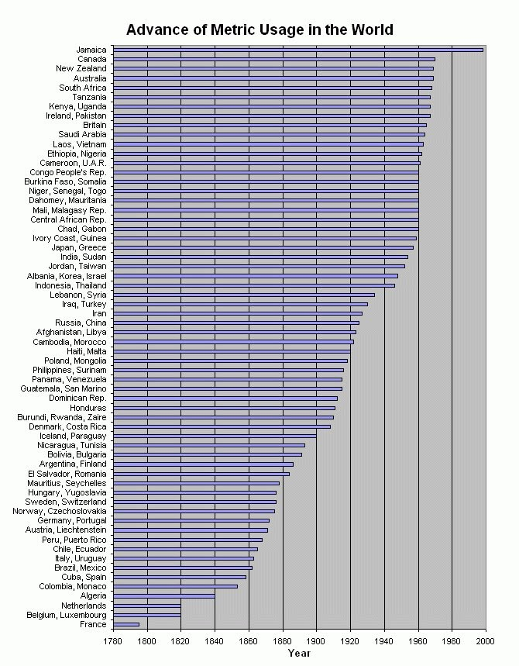

Non-SI Units Commonly Used
1) Liter: symbol = L. The SI unit for volume is m³ (cubic meter). One dm³ (cubic decimeter) equals one L. A cubic decimeter is a cube 0.1 m on a side..
2) cubic centimeter: symbol = cm³. Often used for measuring the volume of solids, one cm³ equals one milliliter (mL).
3) Ångström: symbol = Å. One Å equals 10¯⁸ cm

The Prefixes

In order to properly convert from one metric unit to another, you must have the prefixes memorized.
You will also need to determine which of two prefixes represents a bigger amount AND you will also need to determine the exponential "distance" between two prefixes.
A metric prefix is a modifier on the root word and it tells us the unit of measure. For example, centigram means we are count in steps of one one-hundreth of a gram, μg means millionths of a gram.
A List of the Metric Prefixes
 |  | Multiplier
Prefix | Symbol | Numerical | Exponential
yotta | Y | 1,000,000,000,000,000,000,000,000 | 10²⁴
zetta | Z | 1,000,000,000,000,000,000,000 | 10²¹
exa | E | 1,000,000,000,000,000,000 | 10¹⁸
peta | P | 1,000,000,000,000,000 | 10¹⁵
tera | T | 1,000,000,000,000 | 10¹²
giga | G | 1,000,000,000 | 10⁹
mega | M | 1,000,000 | 10⁶
kilo | k | 1,000 | 10³
hecto | h | 100 | 10²
deca | da | 10 | 10¹
no prefix means: |  | 1 | 10⁰
deci | d | 0.1 | 10¯¹
centi | c | 0.01 | 10¯²
milli | m | 0.001 | 10¯³
micro | μ | 0.000001 | 10¯⁶
nano | n | 0.000000001 | 10¯⁹
pico | p | 0.000000000001 | 10¯¹²
femto | f | 0.000000000000001 | 10¯¹⁵
atto | a | 0.000000000000000001 | 10¯¹⁸
zepto | z | 0.000000000000000000001 | 10¯²¹
yocto | y | 0.000000000000000000000001 | 10¯²⁴

In order to solve conversion problems you will need to determine the exponential distance between two prefixes. For example, the absolute distance between milli and centi is 10¹ (or 1 decimal point). The distance between kilo and centi is 10⁵(or 5 decimal points)
What you should do is compare the two exponents as if they were placed on a number line made of exponents and the compute the absolute distance between them. The key word is absolute. For example, someone might mentally do the distance between kilo and centi by comparing the exponents of 3 and negative 2 and getting one. So they reason the distance is 10¹. They would be wrong.

