“RESTORING BALANCE” NAME ___________________________

L’Chatelier’s Principle DATE_____________________ Pd _____

Introduction
Chemical equilibrium is a true balancing act. What happens when the balance is disturbed? The purpose of this lab is to observe the effects of concentration and temperature on equilibrium and to visualize how balance can be restored based on L’Chatelier’s Principle.

The following is the balanced equation you will be using today. It includes two “complex ions” of cobalt. One of the complex ions involves cobalt and chloride ions combined, the other, cobalt and water combined. Each complex ion is a different color as shown below:

(pink) (blue)

Procedure
Preparation
1. Prepare hot-water and ice-water baths for Part B: Fill a 250-mL beaker with approximately 100 mL of tap water. Place it on a hot plate and heat on medium heat for use in step 13. In a second 250-mL beaker, add several ice cubes to 100 mL water for use in step 14.

2. Obtain a beaker containing about 20 mL of a 1% solution of cobalt chloride in alcohol.

3. Label six dry test tubes A-F and place them in a test tube rack. Also obtain a plastic pipette (rinse and return when finished with experiment).

Part A: Effect of Concentration
4. Using a pipette 1 pipette full of the blue cobalt chloride solution to each test tube A-F. Note: The exact volume is not important, but try to keep the volume of solution approximately equal in each test tube (you may not use all of solution; leave excess in beaker for next class).

5. Set aside test tube A as a control. Record the color and appearance of the control solution in the data table.

6. Half fill beaker with tap water. To test tube B, add 10 drops of tap water, 2 drops at a time. Record the color of the solution after first 2 drops, second 2 drops, third 2 drops, and after last 3 drops.

7. Add 10 drops of water to each of the next three test tubes C,D, and E. Note: The color of the solutions should be the same in test tubes B-E at this point.

8. Take the test tube rack to the fume hood. Instructor will add 10 drops of concentrated hydrochloric acid to test tube C. CAUTION: DO NOT BREATHE IN ACID FUMES!
9. Gently swirl test tube C to mix the contents, then return to your lab station. Record the color of the solution in the data table.

10. To test tube D, add 2 small pellets of solid calcium chloride (carry rack to goggle station, use forceps to add pellets). Let the pellets sit for approx. 30 seconds and observe. Swirl the test-tube to dissolve more of the solid (OK if not all dissolves). Record the color and appearance of the solution in the data table. (add updates to observation as experiment goes on if necessary).

11. To test tube E, add about 25 drops of acetone (until a permanent color change is observed). Gently swirl the test tube contents and record the color of the solution in the data table. (due to low IMF, acetone does not easily stay in pipette; acetone will leave pipette when turned vertical)

12. To the last tube F, add 10 drops of 0.1 M silver nitrate and gently swirl to mix the contents. Record the color and appearance of the mixture in the data table.

Part B: Effect of Temperature
13. Place tube B from part A in the hot-water bath for 2-3 minutes. Record the initial and final color of the solution in the data table.

14. Place tube C from Part A in the ice-water bath for 5 minutes. Record the initial and final color of the solution in the data table.

15. Rinse all test tubes down drain with ample water, turn tubes upside down on rack to dry and return to by goggle station.

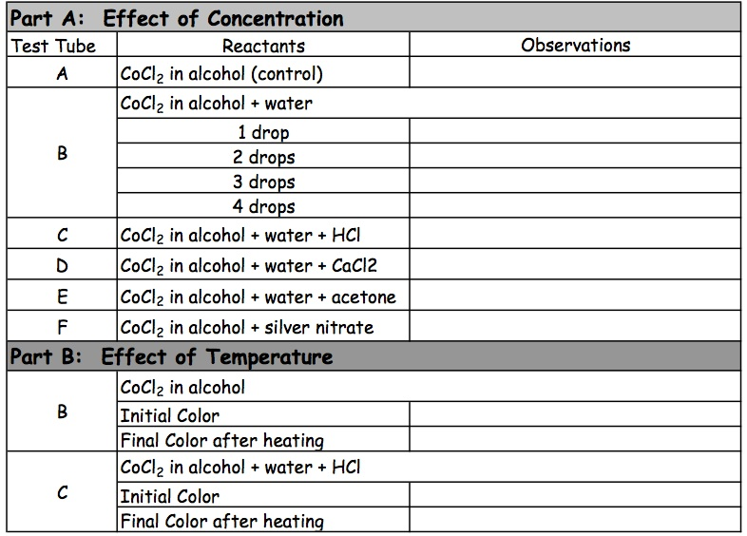

Post-Lab Questions
1) Observe the equation given in the pre-lab for the cobalt(II) chloride reaction. Based on the initial color of the cobalt(II) chloride solution (test tube A), what complex ions are present in this solution? Explain.

2) Which complex ion was favored by the addition of water to the original solution (Test Tube B). Use L’Chatelier’s principle to explain the observed color change.

3) (a) Which complex ion was favored by the addition of hydrochloric acid and calcium chloride in tubes C and D, respectively? _______________________________
(b) What ion is common to both of the reactants added in test tubes C and D? _______________
(c) Use L’Chatelier’s principle to explain the color changes in tubes C and D.

4) Observe the chemical bottle of the calcium chloride (found behind watch glass); read potential uses for the compound. Describe another reason the reaction shifted the way it did when the compound was added (besides the reason stated in #3).

5) Acetone is a polar solvent that attracts water molecules. Use this fact and L’Chatelier’s principle to explain the color change that was observed when acetone was added to tube E.

6) (a) Silver chloride is a white solid that is insoluble in water. Write a net ionic equation for the reaction of silver ions and chloride ions to form silver chloride. _______________________________
(b) Based on this reaction, did the concentration of chloride ions in test tube F increase or decrease when silver ions (in the form of silver nitrate) were added? increase decrease (circle)
(c) Use these facts and L’Chatelier’s Principle to explain the changes observed in test tube F when silver nitrate was added. Be specific.

7) Which complex ion was favored when the solution was heated? Which complex ion was favored when the solution was cooled? Use this information to determine if the reaction is endothermic or exothermic. Explain

