Mass-Mass Problems

This is the most common type of stoichiometric problem in high school.
There are four steps involved in solving these problems:
- Make sure you are working with a properly balanced equation.
- Convert grams of the substance given in the problem to moles.
- Construct two ratios - one from the problem and one from the equation and set them equal. Solve for "x," which is usually found in the ratio from the problem.
- Convert moles of the substance just solved for into grams.
Comments
- Double check the equation. I have seen lots of students go right ahead and solve using the unbalanced equation supplied in the problem (or test question for that matter).
- DON'T use the same molar mass in steps two and four. You have been warned!
- Don't multiply the molar mass of a substance by the coefficient in the problem BEFORE using it in one of the steps above. For example, if the formula says 2 H₂O, DON'T use 36.0 g/mol, use 18.0 g/mol.
- Don't round off until the very last answer. In other words, don't clear your calculator after step two and write down a value of 3 or 4 significant figures to use in the next step. Round off only once after all calculations are done.
With regard to that last comment, if you can use a spreadsheet, you may wish to investigate how to set up a simple formula to solve the problem for you when you put in the proper values.

STOP!!!
Go back to the start of this file and re-read it. Notice that I give four steps (and some advice) in how to solve the example problems just below. In class I gave three. My advice is to keep going back to those steps as you examine the samples below.

Here is a 4K GIF of the steps involved in solving mass-mass problems. It is offered without comment.
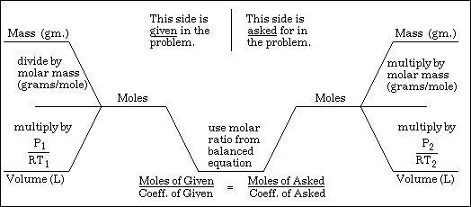
As you can see, the bottom portion includes mass-volume problems using gas Laws. These type problems are not discussed in this file, but in another.

Each of the example problems below has an associated image which lays out the solution. Reading from left to right, the top row gives:
1. the molar ratio used in the problem's solution.
2. the conversion of the grams given in the problem to moles.
The second row gives:
3. the molar proportion used to convert from moles of the given to moles of the unknown.
4. the conversion of moles of the unknown back to grams.
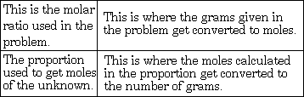

Example #1 - How many grams of chlorine can be liberated from the decomposition of 64.0 g. of AuCl₃ by this reaction: 2 AuCl₃ 2 Au + 3 Cl₂
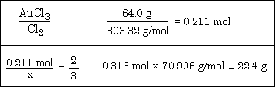

One question I often get is "Where did the value of 303.32 come from?" Answer - it's the molar mass of AuCl₃. Keep this answer in mind as you wonder about where other numbers come from in a given solution.
You might also want to consider looking at the solution to the problem and try to fit it to the list of steps given above. I know what I am suggesting is horrible and very mean, but then, I'm a teacher. What the heck do I know?

Example #2 - Calculate the mass of AgCl that can be prepared from 200. g of AlCl₃ and sufficient AgNO₃, using this equation: 3 AgNO₃ + AlCl₃ --> 3 AgCl + Al(NO₃)₃
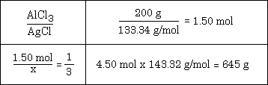
Example #3 - Given this equation: 2 KI + Pb(NO₃)₂ --> PbI₂ + 2 KNO₃ calculate mass of PbI₂ produced by reacting of 30.0 g KI with excess Pb(NO₃)₂
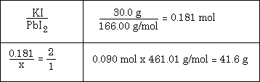
Example #4 - How many grams of AuCl₃ can be made from 100.0 grams of chlorine by this reaction: 2 Au + 3 Cl₂ ---> 2 AuCl₃
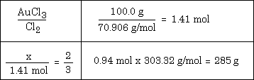
Example #5 - How many grams of Na are required to react completely with 75.0 grams of chlorine using this reaction: 2 Na + Cl₂ ---> 2 NaCl
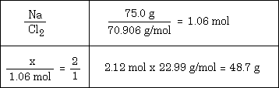

I hope this has been helpful.

