Matter Classification Scheme
One classification scheme for matter can follow the diagram below.

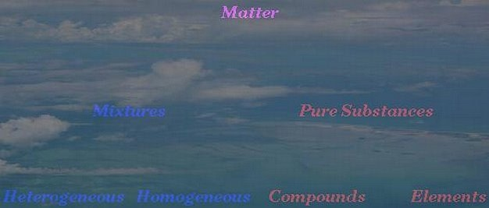

Mixture
Two or more substances, combined in varying proportions - each retaining its own specific properties. The components of a mixture can be separated by physical means, i.e. without the making and breaking of chemical bonds.
Examples: Air, table salt thoroughly dissolved in water, milk, wood, and concrete.
Heterogeneous Mixture
Mixture in which the properties and composition are not uniform throughout the sample.
Examples: Milk, wood, and concrete.
Homogeneous Mixture
Mixture in which the properties and composition are uniform throughout the sample. Such mixtures are termed solutions.
Examples: Air and table salt thoroughly dissolved in water.

Pure Substance
A substance with constant composition. Can be classified an either an element or as a compound.
Examples: Table salt (sodium chloride, NaCl), sugar (sucrose, C₁₂H₂₂O₁₁), water (H₂O), iron (Fe), copper (Cu), and oxygen (O₂).
Element
A substance that cannot be separated into two or more substances by ordinary chemical (or physical) means. We use the term ordinary chemical means to exclude nuclear reactions. Elements are composed of only one kind of atom.
Examples: Iron (Fe), copper (Cu), and oxygen (O₂).
Compound
A substance that contains two or more elements, in definite proportion by weight. The composition of a pure compound will be invariant, regardless of the method of preparation. Compounds are composed of more than one kind of atom. The term molecule is often used for the smallest unit of a compound that still retains all of the properties of the compound.
Examples: Table salt (sodium chloride, NaCl), sugar (sucrose, C₁₂H₂₂O₁₁), and water (H₂O).

