SI Conversions
Here are two typical metric conversion problems:

1) Convert 2.50 mg to picograms.
2) Convert 0.080 cm to km.

A slightly more complex one is:

3) Convert the speed of light (3.00 x 10⁸ m/sec) to km/year.

The key skill in solving these problems is to construct a conversion factor. This conversion factor will make the old unit go away (micrograms and cm in the top two examples) and create the new unit (pm and km) in its place. Along with this change, there will be a change in the value of the number.

Let's focus on the first example: Convert 2.50 mg to picograms

STEP ONE: Write the value (and its unit) from the problem, then in order write: 1) a multiplication sign, 2) a fraction bar, 3) an equals sign, and 4) the unit in the answer. Put a gap between 3 and 4. All that looks like this:
The fraction bar will have the conversion factor. There will be a number and a unit in the numerator and the denominator.

STEP TWO: Write the unit from the problem in the denominator of the conversion factor, like this:
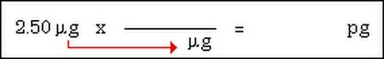
STEP THREE: Write the unit expected in the answer in the numerator of the conversion factor.
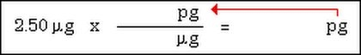
STEP FOUR: Examine the two prefixes in the conversion factor. In front of the LARGER one, put a one.
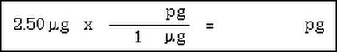
There is a reason for this. I'll get to it in a second.

STEP FIVE: Determine the absolute distance between the two prefixes in the conversion unit. Write it as a positive exponent in front of the other prefix.
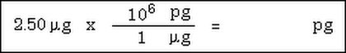
Now, multiply and put into proper scientific notation format. Don't forget to write the new unit. Sometimes, the exponential number is in the denominator. You must move it to the numerator and when you do so, remember to change the sign. Also, DO NOT move the unit with it. That unit has been cancelled and is no longer there.

The final answer then becomes: 2.50 x 10⁶ pg

Here are all five steps for the second example, put into one image:
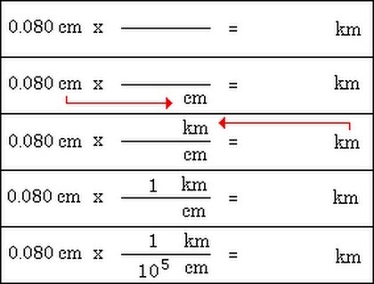
Note that the old unit cancels, since it appears in the numerator and denominator of two parts of a multiplication problem.

The final answer then becomes: 0.0000008 or 8.0 x 10⁻⁷

Why a one in front of the larger unit? I believe it is easier to visualize how many small parts make up one bigger part, like 1000 m make up one km. Going the other way, visualizing what part a larger unit is of one smaller unit, is possible, but requires more sophistication. For example, how many meters are in one nanometer? The answer is 0.000000001 or 10⁻⁹. You may be able to handle the conversion and that is just fine. I'm just trying to make it simple.

3) Here is the problem:

Convert the speed of light (3.00 x 10⁸ m/sec) to km/year.

Doing this type of problem is simply a succession of conversions from one unit to another. You first convert one side of the fraction, then the other. We'll start with the numerator, since that's an easy, one step conversion.
This gives an answer of 3.00 x 10⁵ km/sec.

Now, we have to focus on converting seconds to years. This is done in a step-by-step manner. For example, I happen to have memorized that there are 3600 seconds in one hour. So, we do that conversion.
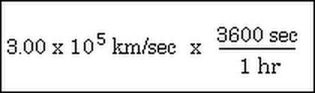
Continuing the calculations, we move step-by-step to days and then to years (we can skip months, since we know how many days there are in a year.
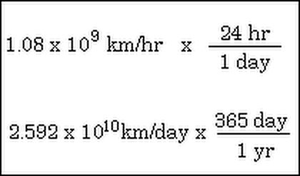

Converting to scientific notation and rounding to three significant figures, we get 9.46 x 10¹² km/yr as the answer.

